Laboratory Activity
Web Systems and Technology
Midterm

Procedure:

- Open the XAMPP control panel (see image)
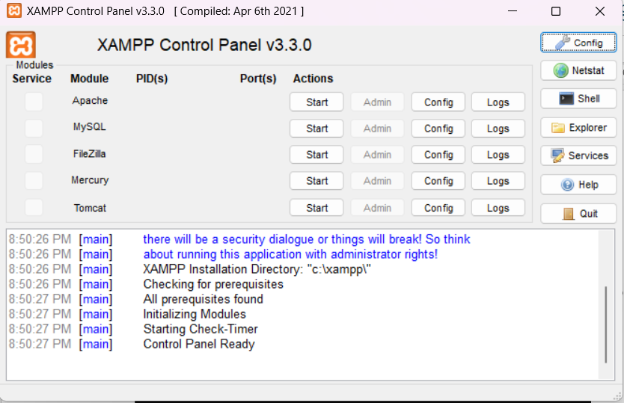
Make sure to click the Start button to open the Apache and MySQL

- Once it green your server is now running
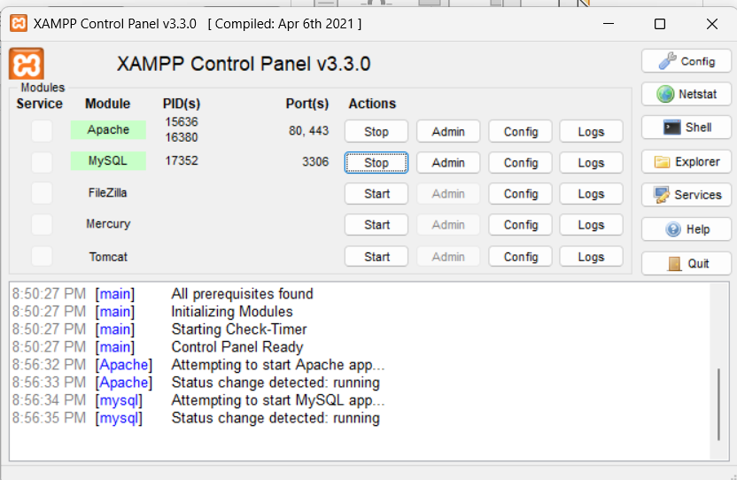

- Make sure to check the ports of Apache and MySQL as follows
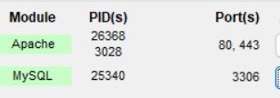
- Your now ready to test your server
- Access the XAMPP dashboard in a browser
  - Open your preferred web browser and type http://localhost into the address bar and press Enter.
  - If XAMPP is working correctly, you will see the XAMPP welcome page, which confirms the Apache web server is running.
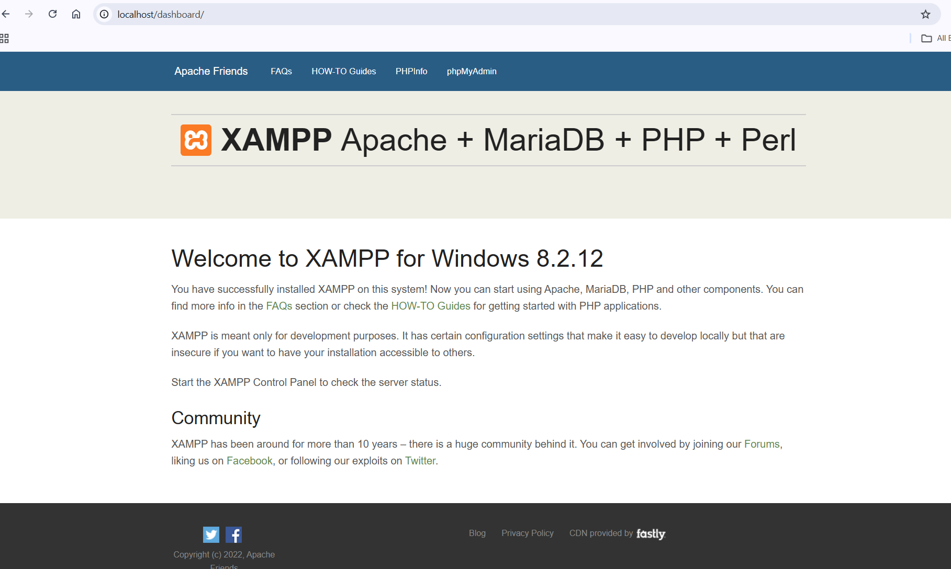
  - Alternatively, you can type http://127.0.0.1 to get the same result.
- Then go to your phpMyAdmin inside your XAMPP control panel (click ADMIN under MYsQL)
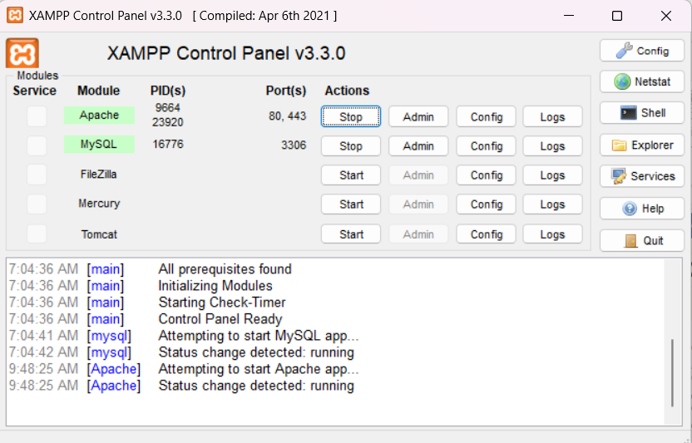

- Then it will redirect you to the admin panel
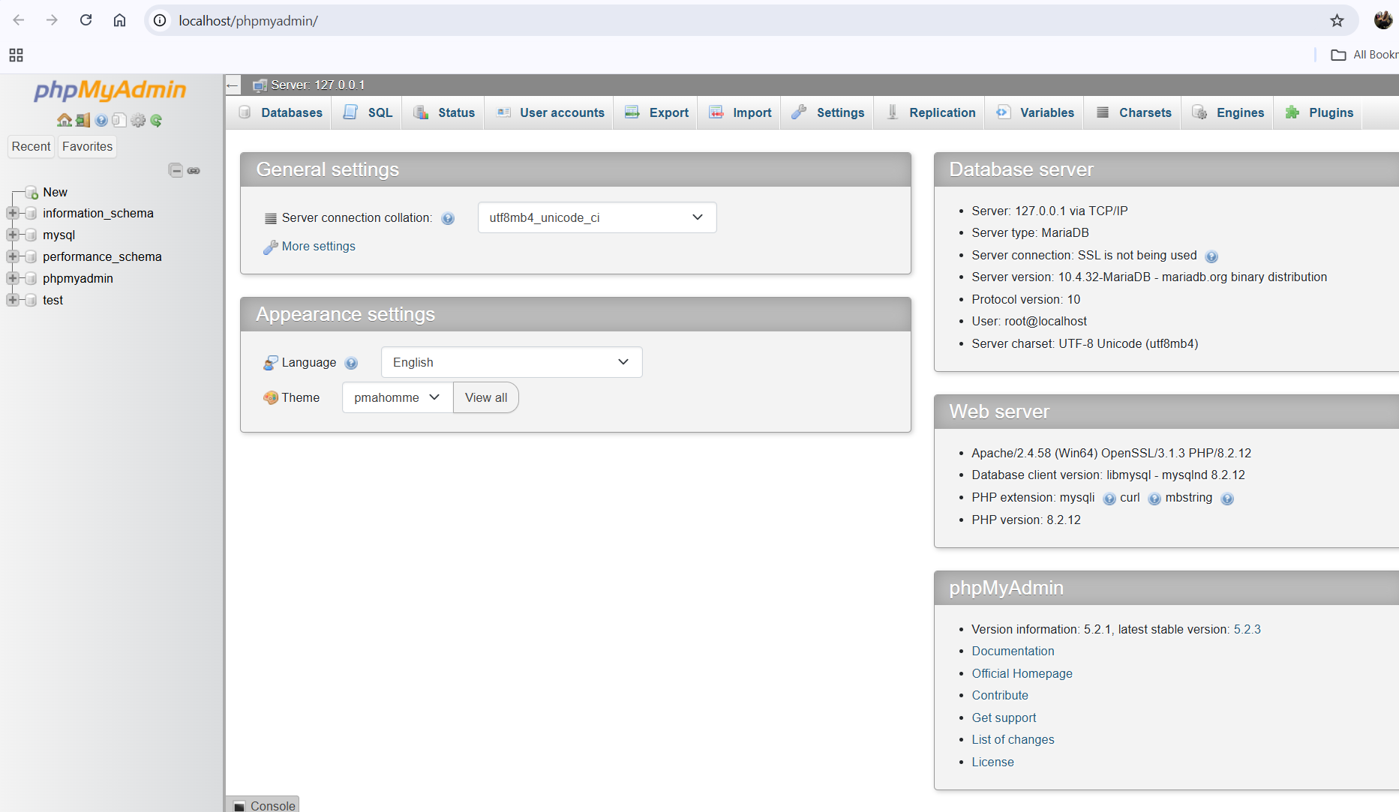

Once open do the following:
- I want you to explore or try to create a sample database as your activity for today.
- Name it on the desired name.
- Screenshot all your works and output in this document and sent it through your github (filename: Activity 3 -10/28 ) this is a different filename from your Activity 2.

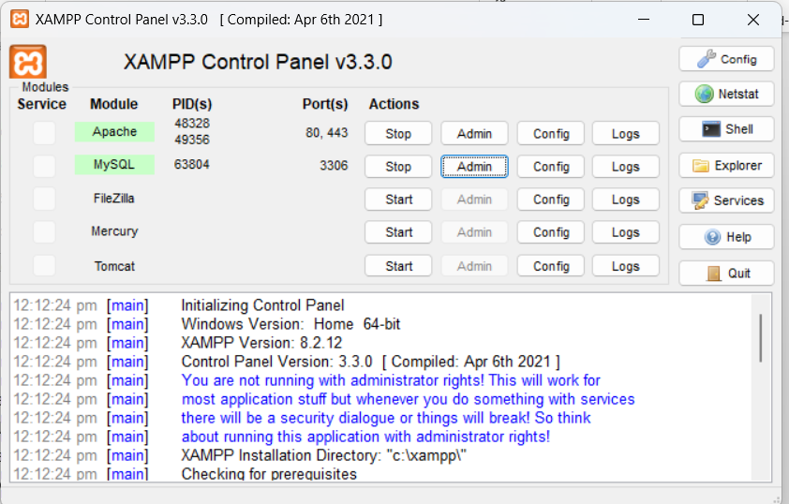
Screenshots:

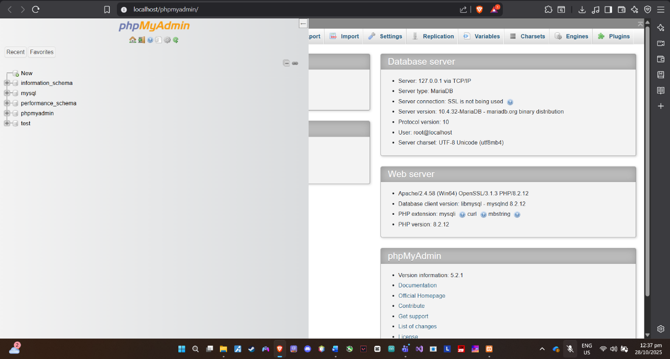
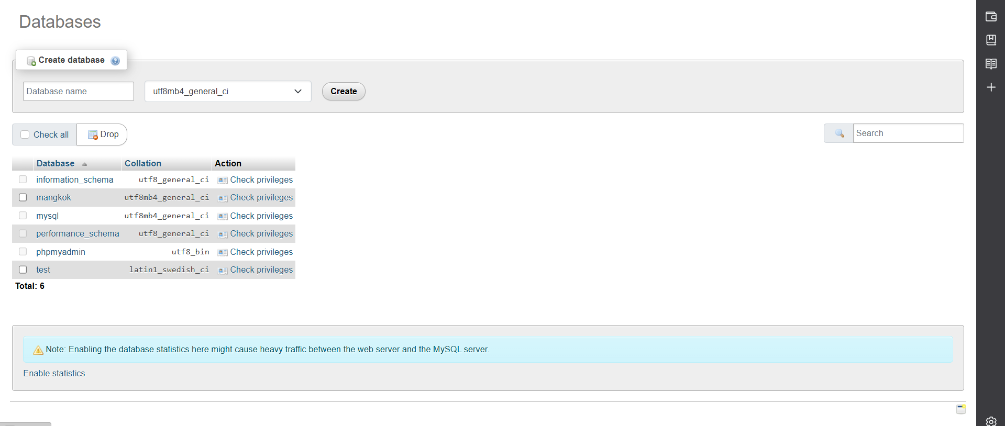
Created new database “mangkok” :

Created table “Customer”:
